**IMPLEMENTATION PROJECT**

**PLAN**

**< Robotic Arm >**

**IMPLEMENTATION PLAN**

**06/18/2021**

# TABLE OF CONTENTS PAGE

# 

1. ORGANIZATIONAL STRUCTURE…………………………………………………………………………1

2. PROJECT DEFINITION FORM………………………………………………………………..……………2

3. MAJOR TASKS………………………………………………………………………………………………3

4 IMPLEMENTATION SCHEDULE.........................................................................................................3

5. TASKS ANALYSIST……………………………………………………………………………………...…..4

6. IMPLEMENTATION SUPPORT…………………………………………………………………………..…8

7. PERFORMANCE MONITORING……………………………………………………………………….…8

8. ACCEPTANCE CR ITERIA…………………………………………………………………………………8

9. PROGRESS REPORT ……………………………………………………………………………………….9

10.PRPJECT MANAGEMENT CHECKLIST………………………………………………………………….10

11. PROJECT PRODUCTION LINE……………………..……………………………………………………11

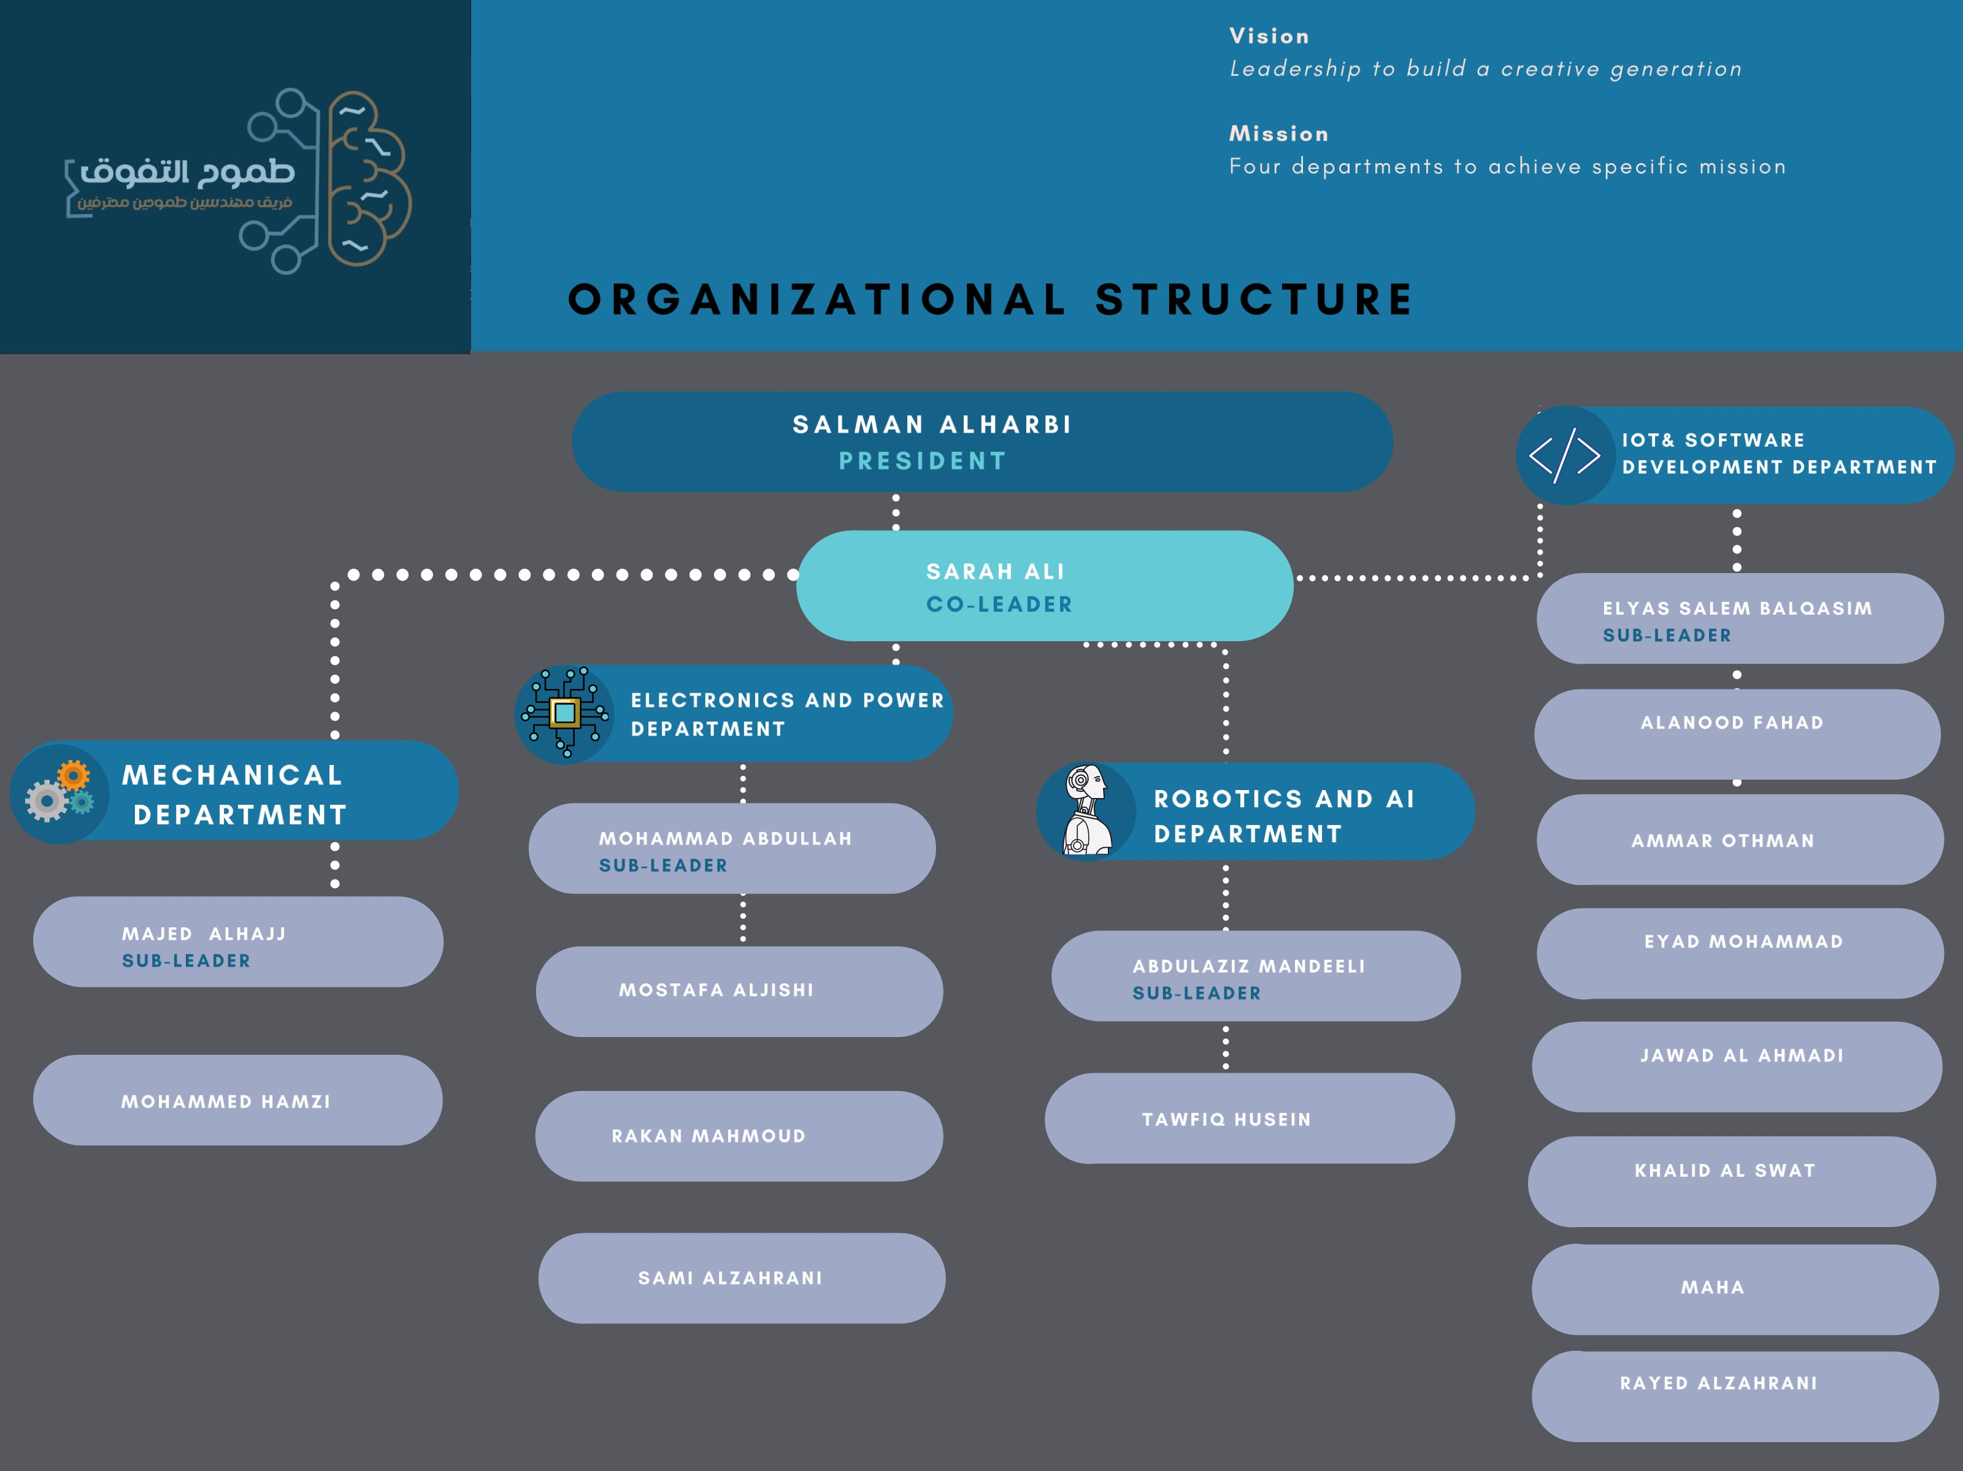

**1.**

**2. PROJECT DEFINITION FORM**

|  |  |
| --- | --- |
| **PROJECT TITLE** | Participating with you on the robotics fight & to use our information on some of the missions. |
| **PROJECT LEADER** | Industrial Engineers |
| **COMPANY NAME** | Smart Methods |
| **BRIEF PROJECT BACKGROUND** | A robotic arm is a type of mechanical arm, usually programmable, with similar functions to a human arm. A typical robotic arm has the following components: Links and joints, Actuators, Controller, End-effector, and Sensor.  1- Links and joints: A link is considered as a rigid body that defines the relationship between two neighboring joint axes of a manipulator. Manipulators consist of rigid links, which are connected by joints that allow relative motion of neighboring links. The links move to position the end-effector.  2- Actuators: Actuators play the same role the muscles play in the human arm - they convert stored energy into movement. Actuators are used to move a robot’s manipulator joints, the actuator can be pneumatic, hydraulic and electrical actuator but in our project, we used electrical actuators.  3- The controller: is the main device that processes information and carries out instructions in a robot. It is the robot's 'brain' and controls the robot's movements.  4- End-effector: In robotics, an end-effector is the device at the end of a robotic arm, designed to interact with the environment.  5- Sensor: It is a small device that attract with the input from the environment, and the purpose of knowing where the robotic arm is and where it is going. |
| **PROJECT BENEFITS** | * learning by working on real projects * Clearing specific missions * How to work with an Engineering teams * High Quality and Effective work |
| **SYSTEM IMPLEMENTATION** | * Dividing the work for the participants. * Receiving the missions from them. * Looking at what they have done? How they did it? and How to improve it? * Accepting or declining the work * Receiving results. |
| **PROJECT TIMELINE** | 4 weeks  That is the longest task. We will work at the same time but after we know what we are doing and how. |
| **PROJECT COST** | We will search about it and report it |
| **MEASURABLE CRITERIA FOR SUCCESS** | If the result can be measured.  If the measures meet the standard.  If the experiment is measurable. |

**3. MAJOR TASKS**

*These are the following information for the description of each major task, if appropriate:*

* *What the task will accomplish*
* *Resources required to accomplish the task*
* *Key person(s) responsible for the task*
* *Criteria for successful completion of the task: The report (e.g., “user acceptance”)*

**4. IMPLEMENTATION SCHEDULE**

*There is a schedule of activities in Google Sheets to be accomplished that show the required tasks (described in section 3. Major Tasks) in chronological order, with the beginning and end dates of each task.*

*Here the Excel File of group members’ work:*

[*Implementation Plan*](Smart%20Method%20s/Project.xlsx)

**5. Tasks ANALYSIS**

|  |  |  |
| --- | --- | --- |
| **DEPARTMENT** | | |
| 1- Mechanical | | |
| Week | N. Task | Task Description |
| 2 | 1 | Download the arm &Installation the part at any 3D Program |
| 2 | Write an explanation of the installation steps |
| 3 | Design your new end effector that is appropriate of this mission |
| 4 | Creating PHP page to connect data with hardware |
| 3 | 1 |  |
| 2 |  |
| 3 |  |
| 4 | 1 |  |
| 2 |  |
| 3 |  |
| 5 | 1 |  |
| 2 |  |
| 3 |  |
| 6 | 1 |  |
| 2 |  |
| 3 |  |

|  |  |  |
| --- | --- | --- |
| 2- Electronics and Power | | |
| Week | N. Task | Task Description |
| 2 | 1 | Design the electric circle to control by 7 servo engines |
| 2 | Programming the circuit to move 180 degrees to achieve the best freedom and flexibility |
| 3 | Programming the engines by using variable resistance |
| 3 | 1 |  |
| 2 |  |
| 3 |  |
| 4 | 1 |  |
| 2 |  |
| 3 |  |
| 5 | 1 |  |
| 2 |  |
| 3 |  |
| 6 | 1 |  |
| 2 |  |
| 3 |  |

|  |  |  |
| --- | --- | --- |
| 3- Robotics & AI | | |
| Week | N. Task | Task Description |
| 2 | 1 | Using the Ros system with the control penile |
| 2 | Writing how did you do it |
| 3 | Writing codes by using C++ or Python |
| 3 | 1 |  |
| 2 |  |
| 3 |  |
| 4 | 1 |  |
| 2 |  |
| 3 |  |
| 5 | 1 |  |
| 2 |  |
| 3 |  |
| 6 | 1 |  |
| 2 |  |
| 3 |  |

|  |  |  |
| --- | --- | --- |
| 4- IOT & Software Development | | |
| Week | N. Task | Task Description |
| 2 | 1 | Designing the front-end page |
| 2 | Creating data base to control the arm |
| 3 | Design the back end ,eg(Connecting the data base with the front end ) |
| 4 | Creating PHP page to connect data with hardware |
| 3 | 1 |  |
| 2 |  |
| 3 |  |
| 4 | 1 |  |
| 2 |  |
| 3 |  |
| 5 | 1 |  |
| 2 |  |
| 3 |  |
| 6 | 1 |  |
| 2 |  |
| 3 |  |

|  |  |  |
| --- | --- | --- |
| 5- Industrial Engineering | | |
| Week | N. Task | Task Description |
| 2 | 1 | Writing the project paper |
| 2 | Helping the team members, organizing the whole process |
| 3 |
| 3 | 1 |  |
| 2 |  |
| 3 |  |
| 4 | 1 |  |
| 2 |  |
| 3 |  |
| 5 | 1 |  |
| 2 |  |
| 3 |  |
| 6 | 1 |  |
| 2 |  |
| 3 |  |

**6. IMPLEMENTATION SUPPORTS**

Describe any support hardware, software, facilities, and materials required for the implementation,

* Hardware

We will search more and then will order it.

* Software

We will search more and then will order it.

* Facilities

We will search more and then will order it.

* Materials

We will search more and then will order it.

**7. PERFORMANCE MONITORING**

1-We will Use a reporting system.

2-We will accept the work or ask to re-do it again.

3-We will use google docs.

**8.** **ACCEPTANCE CRITERIA**

The project will be accepted if the result meet:

1- freedom

2-easy to use

3-readme file in a specific questions and answers:

1- What did you do?

2- How did you do it?

3- How will you improve it?

**9. progress report**

The report has these questions and you have to answer them.

you need to answer specifically

What did you do ?

How to improve it if possible, if not why ?

How long did it take ?

What skills did you need ?

What was hard?

How did you do it ?

the readme file can have the report.

|  |  |  |  |  |  |  |  |  |  |  |  |  |  |  |  |  |
| --- | --- | --- | --- | --- | --- | --- | --- | --- | --- | --- | --- | --- | --- | --- | --- | --- |
| **PROJECT NAME** | | Robotic arm | | | | | | **PROJECT**  **LEADER** | | | Salman & Sarah | | | | | |
| **DATE PREPARED** | | 6/21/2021 | | | | | | **REPORTING PERIOD** | | | One week | | | | | |
| **PREPARED BY** | | Sarah Ali Alshahrani & Salman Faisal alharbi | | | | | | **PROJECT STATUS** | | | In Progress | | | | | |
| **KEY DELIVERABLES THAT COMPLETED IN THIS PERIOD** | | | | | | **DELIVERABLES OUTSTANDING** | | | | | | | **DELIVERY DATE** | | **DELIVERABLES FOR NEXT PERIOD** | | | | | | **DELIVERY DATE** | |
| Project Paper | | | | | | Helping and organizing the team | | | | | | | 6/21 | |  | | | | | |  | |
|  | | | | | |  | | | | | | |  | |  | | | | | |  | |
|  | | | | | |  | | | | | | |  | |  | | | | | |  | |
| **FINANCIAL STATEMENT** | | | | | | | | | | | | | | | | | | | | | | |
| **CAPITAL** | | | | | | | **REVENUE** | | | | | | | | | **EXTERNAL** | | | | | | |
| **Source** | **Budget** | | **Actual** | **Remain** | **Forecast** | | **Source** | | **Budget** | **Actual** | | **Remain** | | **Forecast** | | **Source** | | **Budget** | **Actual** | **Remain** | | **Forecast** |
|  |  | |  |  |  | |  | |  |  | |  | |  | |  | |  |  |  | |  |

**10. PROJECT MANAGEMENT CHECKLIST**

STATUS: **N** = Not Yet Started • **P** = In Progress • **C** = Complete

|  |  |  |
| --- | --- | --- |
| **ACTIVITY** | **STATUS:**  **N • P • C** | **COMMENTS** |
| **SET UP / INITIATION & DEFINITION** |  |  |
| Project Definition Form complete | C |  |
| Roles defined and documented | C |  |
| Clear levels of authority defined | P |  |
| Project Review procedure developed | P |  |
| Team selected and evaluated for project needs | P |  |
| **DELIVERY PLANNING** |  |  |
| Work Breakdown created |  |  |
| Evaluate estimates for accuracy |  |  |
| Milestone or Gantt Chart developed |  |  |
| Budget developed and reviewed |  |  |
| Measurements for Success developed |  |  |
| **DELIVERY EXECUTION** |  |  |
| Planned vs. Actual Schedule developed |  |  |
| **PROJECT COMPLETION AND REVIEW** |  |  |
| Project Review process defined |  |  |
| Project Success monitoring |  |  |
| Project Completion Reports produced and distributed |  |  |

**11. PROJECT production line**

1. **Modeling Methods :**
2. **CNC**
3. **3D Printing**
4. **casting**

**2- ASSeMBLY:**

1. **AUTOMATED ( It will be 100%)**
2. **MANUAL (Now it is 100% )**

**3-packaging :**

1. **box**

**4-PROGRAMS:**

1. **Google Docs**
2. **Google Sheets**
3. **Telegram**
4. **Web SM**
5. **WhatsApp**